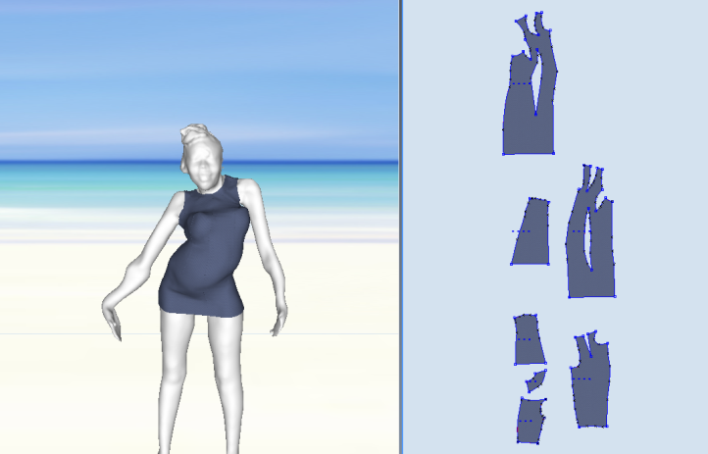
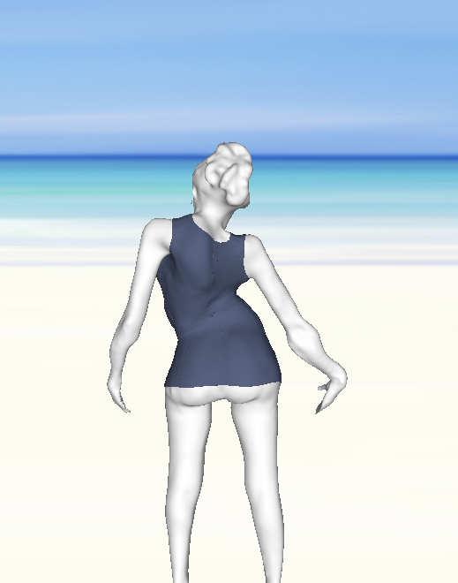
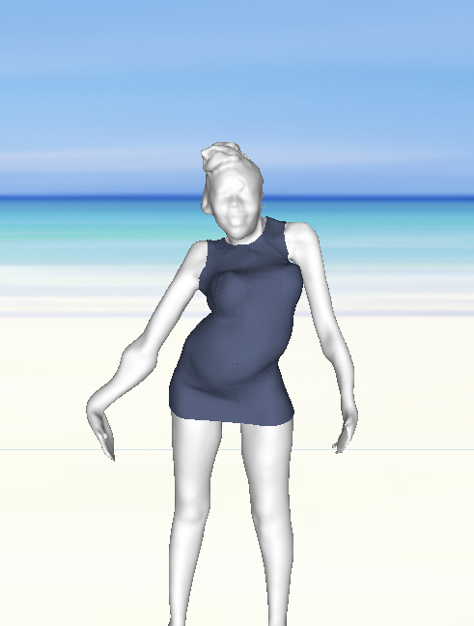

Figure 1: Customized garment design for scoliosis patients using CAD tools (interactions between 3D virtual garment fitting and 2D garment patterns generation)
Figure 2: A FDM 3D printer and a textile fabric with 3D printed geometric structure (from reference [16])
Figure 3: Classical corset for correcting body deformation (hard material, uncomfortable, bad appearance)

Figure 4: Required innovative corset (soft, natural appearance, comfortable, easy to wear) (from the reference [4])

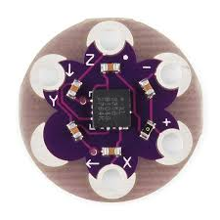
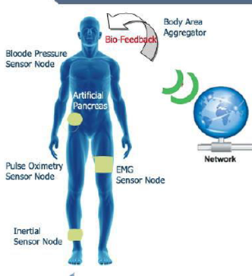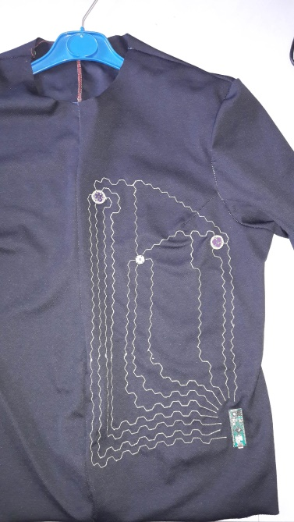
Sensors
Conductive yarn
a silver-plated, antibacterial and antistatic polyamide yarn.
Path in hexagon allows a good mechanical deformation thus keeps the elasticity and reduces the risk of breakage of the wire.

Microcontroller
Figure 5: General principle of an intelligent and connected garment for online human health monitoring and one prototype
Sensors
Conductive yarn
a silver-plated, antibacterial and antistatic polyamide yarn.
Path in hexagon allows a good mechanical deformation thus keeps the elasticity and reduces the risk of breakage of the wire.

Microcontroller
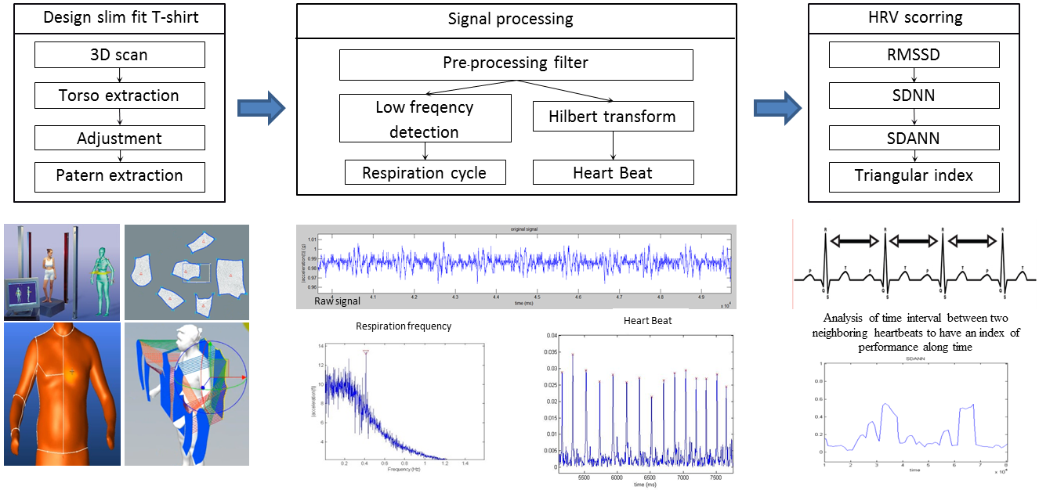


Figure 6: Design process of a customized intelligent garment (customized garment design, integration of devices, signal preprocessing and decision support unit development)
cloud
Intelligent garment

Figure 7: Architecture of communication between the proposed intelligent garment, smartphone and cloud platform
Patient 1

Patient 2

Patient n

Figure 8: General structure of the proposed intelligent garment connected to a cloud platform

